Internal Quality Assurance in University of Latvia. Features to be Exploited in Partner Countries
Dr. Alberts Prikulis, Lead Researcher, University of Latvia

Basic facts

Latvia, with the capital city Riga is situated in Northern Europe, on the coast of Baltic Sea. Latvia as a National state was founded on November 18, 1918; between 1940 and 1991 it was incorporated in the USSR; since 1991 it is again an independent country. It joined the European Union in 2004 and Eurozone in 2014.

The main exports: logistics, high-tech, chemicals, pharmacy, agriculture, woodwork

Its population is 1 984 887 in 2016. Ethnic composition: Latvians 61.4%, Russians 26%, Belarusians 3.4%, Ukrainians 2.3%.

Students: 85.9 thsd in 2015; Higher education institutions (including colleges): 60, out of which 1/3 is state founded. Since 1992 Latvian HEIs participate in European programmes in the field of education. Since 1999 Latvia is participating in Bologna process, and since 2011 its internal quality assurance systems have been developing along the lines of ESG.

University of Latvia was founded on September 28, 1919. It is the largest HEI in Latvia, with over 13 thousand students in 2016

QS World University Rankings 15/16: 651-700

It is a comprehensive type of HEI, containing 13 faculties of all study domains except for engineering (those have been split off in 1958 and form Riga Technical University), it contains also 15 research institutes.

Total number of study programmes is 130 (undergraduate 53, postgraduate 53, doctoral 24). Staff: 2283 (academic 1151, other 1132). Since 2015 it started a new campus, the first faculties to be placed there were Chemistry, Biology and Geography.

What do we mean by quality in HE?

Definition of quality usually refers to either fitness for purpose (for products) or meeting the needs/requirements of client (for services). Why can we apply the definitions to HE at all? The fact is that academic process just as any production process has certain source (raw) material (knowledge and skills of students) that is developed (processed) into some product (knowledge and skills of graduates). The process itself can be considered as a service provided to those who benefit from the ‘product’. What makes HE (and education in general) different is that students are not only connected with the ‘source material’ but also are actors and the main beneficiaries. This should be born in mind when one speaks about students’ role in Quality Assurance (QA)

There are many clients and stakeholders for the academic process, therefore we cannot apply the quality definitions directly. Instead we have certain National and international standards for product and for the process. The product standards are using so called Learning outcomes (LO); the idea developed in Bologna process and finalized as European Qualifications Framework (EQF) and National Qualifications Frameworks (NQF). The academic process called for development of Standards and guidelines for quality assurance in European Higher Education Area (ESG, 2005, which now has been revised).
Both Learning outcomes (LO) and ESG have been used to develop QAS in UL. Each study programme has a description of LO, and these are also reflected in all courses; they also guide the faculty to choose distinct types of teaching and learning and forms of student assessment. The QMS in turn, has ESG as the basis of criteria by which all the processes are evaluated.
As the two partner countries are at dissimilar stages of Bologna, obviously different approaches would be aplied for setting up QAS in HEIs in KZ and UZ. KZ, as a signatory of Bologna declaration can exploit a wider range of Bologna principles than UZ. My contribution – as a member of T2 – must concentrate on aspects relevant for UZ. So, one of the immediate conclusions is that LO approach is less applicable to UZ HEIs, and we did not try to introduce it in the academic process. But it could be relevant, e.g. for KZ universities (or for UZ in future).
ESG, on the other hand served as a good guiding light also for UZ partner institutions, and we shall return to it repeatedly in the further narrative.
One more feature one must mention is the process management. UL has process management as a cornerstone for the QMS, and principles of this approach proved possible to develop also in UZ.
And, last not least, we should mention self-evaluation. Each spring semester the necessary data are collected for this annual exercise, and before the end of the academic year each study programme and each faculty is self-evaluated and the possible and necessary changes in courses and/or programmes made before the beginning of the next academic year. Self-evaluation (which is present also in other HEIs of EU partners) has been introduced also in partner institutions of UZ.

Now we can return to the issue of ESG point by point

1.1. Policy and procedures for QA

Quality policy of UL defines continuous development towards excellence in research-based studies as the aim of Quality assurance system [of studies]. Study processes are clearly structured and there are responsibles for each of them. Collective responsibility belongs to the decision-making bodies – Constitutional assembly, Senate, Committee of assessment of quality of study programmes (CAQSP), Faculty boards and Study programme councils (SPC); they evaluate study quality and decide on measures for ensuring the quality of studies in UL. Administration of UL is responsible for functioning of the QMS and performs monitoring and audits of study process. Several internal regulations have been adopted on this. UL process management module includes all the processes and structural units, which makes its structure difficult to present visually. It is organized as submodules with several levels, the first level submodules being UL management, Strategic planning, Internal audit, Quality management, Administration reports, SCIENCE, STUDIES, INTERACTION WITH SOCIETY, International cooperation. Procurement, Staff management, Project management, Filing, Maintenance of infrastructure, IT management, Fiscal management. The module Studies, in turn, is divided in several submodules, and so on.
Out of this [very complicated and very large] system we have exploited the following parts:
Firstly, we ventured to formulate the quality policy in each institution. The aim of the QA and the QAS in UZ institutions, certainly, are different from UL, but, however, the template was useful, and each HEI put in it its own preferred aims and the lists of the chosen parts of ESG. Another useful feature proved the process management approach, and we developed the necessary minimum of regulatory basis and descriptions of procedures for the selected processes.

1.2 Design and approval of programmes:

There are several regulations that define requirements to study programmes at National level in LV:
Regulation on standard of 1st level professional HE (Cabinet of Ministers)
Regulation on standard of 2nd level professional HE (Cabinet of Ministers)

Also, all the responsibilities and processes are regulated internally (by close to a dozen by-laws). Algorithm of the process of evaluation and adoption of a study programme, starting with preparation of the self-evaluation report and ending with implementation or closure of the study programme (depending on the results of evaluation and accreditation) is rather complicated and involves many actors.

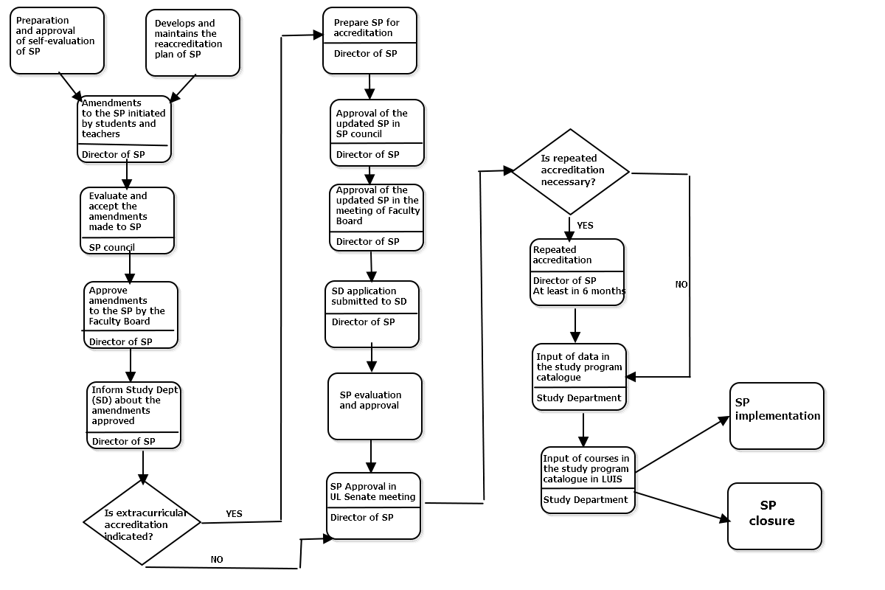
Fig.1. Algorithm of preparation, adoption and revision of study programmes
We admit that creating and modification of study programmes in UZ is done in a centralized way, therefore the algorithm will not be relevant. However, the individual courses are entirely within the competence of faculties, and a process of revision of courses therefore is useful.

1.3 Student-centered learning, teaching and assessment:

Student-centered learning is a rather recent trend in QAS, but nevertheless the best teachers have been exploiting it as an approach in their classes for decades. The main difference (as compared to the period in UL before 1990) is student involvement both in the process (to make it interactive), and in decision-making at all levels. It is firmly embedded in laws and internal regulations of European HEIs, including UL.
All forms of study process at the University of Latvia are chosen by the academic staff. The forms of the study process are:
- Lectures
- Laboratory works
- Practical works (field works in some SP of Natural sciences)
- Seminars
- Practice (industrial placements of varying length)
- Colloquia

Student assessment is done at the level of study programme or individual course, although the procedures are defined in National and internal regulations. There is a dozen of internal regulations referring to this ESG line.
Out of this chapter several processes have been identified as useful parts to be introduced in UZ. These mostly concern student involvement in evaluation of certain parts of the academic process.

1.4 Student admission, progression, recognition and certification:

This chapter deals with a wide range of activities throughout the full cycle from application to studies until issue of graduation papers, and its steps involve a range of responsible persons or units, therefore we also find an extensive list of regulations (around 20), starting with the Law on HEIs (Parliament) and ending with the one on collecting of questionnaires from those who proposed to interrupt their studies (Rector’s order). Information on admission at all the cycles is published at the internet site for applicants. Study results are accounted and maintained in the portal of e-studies.

We admit that these processes are regulated centrally in UZ, and we did not attempt to make changes in this respect.

1.5 Teaching staff:
Teaching staff is one of the crucial things in the academic process, and certain requirements have been established at the National level. Inter alias, there are certain requirements for proportion of staff having academic and scientific degrees, according to National typology of HEIs. Apart from that we have internal regulation on staff. A specific procedure has been defined for election of staff.
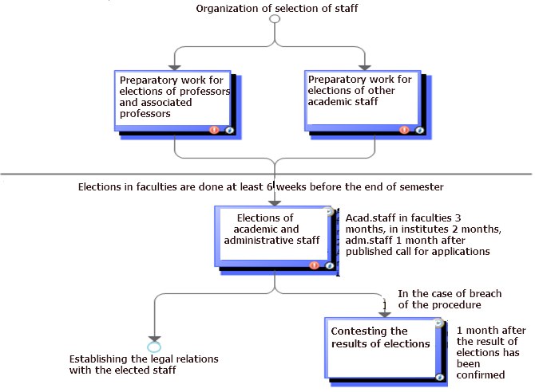

Fig.2. Process of organization of staff elections

It must be mentioned that staff must be elected (or re-elected) on a regular basis, and each time there is an open competition for the position. Only in very specific cases a member of academic staff can be established in his/her position just be rectoral decree; this can be done only twice for the period of 1 year.
The regulation of our institution foresees that before the election, the performance of the candidate is evaluated by colleagues and students (in case of repeated election); if the person is new, he/she is requested to deliver a class on a given topic from one of the prospective courses, and the evaluation is based on this lecture, seminar or such like.
In UZ there is a system of staff recruitment and development, which, although different in detail, follows basically the same route. What turned interesting and useful for UZ partners was the questionnaires used in evaluation of staff, and some processes containing evaluation of staff have found place in the quality handbooks developed in UZ.

1.6 Learning resources and student support:
Institutions should have appropriate funding for learning and teaching activities and ensure that adequate and readily accessible learning and student support are provided.

The main resource is the forms of teaching and learning provided at the SP and individual level. At he institutional level we have many support forms that are maintained adminstratively and financially from the institutional budget.

One of very important – centrally managed – support forms is the institutional library. There are several branches of the library, because the new university campus has just started, and we have the faculties scattered around the city. However, the catalogues can be approached remotely, and the books can be ordered from any branch and delivered to the nearest one to the student. Apart from books and magazines there are vast electronic resources. There are a few internal regulatory acts concerning resources.

MOODLE platform is providing students with the necessary information for the study process on-line – study course content, texts, lecture presentations, description and forms of laboratory works, questions for self-control etc.). During the study process discussion (chat) groups can be developed. The academic staff is responsible for updates of this information.
The study support at the University of Latvia includes the Academic Library, Online study courses (for registered teachers and students, UL provides free software during the studies: Microsoft Office 365, Wolfram Mathematica, SPSS, Gaussian, Autodesk).
The feedback is provided by an online questionnaire for study courses and study programmes quality.
The student support forms are similar in UZ universities, and we did not propose substantial novelties in this chapter. However, the description of all the forms available could help improvement of quality, and it could be recommended that this chapter will be included in quality handbooks in future, e.g. in context of support forms that can help developing certain learning outcomes (when they arrive on the scene).

1.7 Information management:

As concerns the information systems, they are maintained centrally and used by students and academic and administrative staff to store, manage and use the relevant information. The information system of UL (LUIS) contains all the personal data on students and staff (accessible only in an authorised way to meet the requirements of the law on protection of personal data. It also contains all the records concerning the academic process, and the student can always find out what tasks or tests he must perform and what is his/her situation with the academic progress. Here also the students can approach centrally organized questionnaires to leave their opinion on programmes, courses and their staff. These opinions are used, i.a., for election of staff and for renewal or amendment of programmes and courses. The information is accumulated, maintained and processed in LUIS. Information is stored and treated by Data storage unit. Lecturers are well familliar with the system and use it extensively. Each student can find his place in the academic progress, see his/her tasks and records. Lecturers can put their tests and marks to students and see their own results, and the medium-level management can follow the general development of the situation.
Information management in UZ universities is different; as we discovered in discussions with partners, it relies mainly on secretarial work and storage on paper. Neverthelesss, some parts of data management can be implemented. Thus, there are prospects of questionnaires that the institutions will be using, namely, analyses of data in thoses questionnaires and their use by faculties and the central management.

1.8 Public information:

The university makes the information meant to be public mostly electronically (via internet), but there also regularly renewable leaflets on faculties and programmes distributed in information events. There are also periodical publications about faculties and the university in a format of books, also containing quantitative data about the programmes and awards. (Thus, 2 years ago we completed and published a book about 50 years of Chemistry Faculty, containing inter alias a chapter on currently running study programmes).

In the internet, one has special pages for those who would like to study in our university, and theses pages have concise information on programmes and courses. When one enters the page of a study programme, one can see all the basic data about the programme, and the annotation and the description of aims and tasks of the programme. Information is also available in English, only in a different format, because it is meant for foreigners and not all the study programmes have been duplicated in English. The page about admission contains useful tips and advice on how to become our student. Study programmes have a general description in English – as you can see from our Bachelor programme in Chemistry, with attachments containing more detail.

The main novelty we introduced in UZ institutions is the short desriptions of study programmes for the benefit of applicants and of international partners. Another (in one of the institutions), is the intention to publish certain parts of annual institutional reports.

1.9 On-going monitoring and periodic review of programmes:

There are several internal regulations containing reference to the annual monitoring and reviev of study programmes. In our university, this has become a routine, and right now certain procedures are executed (triggered by the Academic Department) and the faculty is actively involved in the process.
In UZ institutions, as it was mentioned before, the process of reviewing the programmes is centraliaed. However, regular evaluation of programmes and courses is being developed, and there are also ways of collecting the feedback and transferring it to the National bodies that carry out revision of programmes at National level.
As an additional novelty (although not taken from UL, but as a spin-off effect) in one of the institutions is concerning the process of industrial practical placements (this process is also linked to 1.3. – student centered learning)

1.10 Cyclic external quality assurance:

HEIs in Latvia undergo external quality assurance in line with the ESG on a cyclic basis (every 6 years). This is regulated on National level by Regulation on accreditation (Cabinet of Ministers)

Accordingly, each study domain (including each study programme) must prepare a self-evaluation report (like annual reports, but taking into consideration specific requirements put forward by the Accreditation agency (at present this function is delegated to Academic Information Center), and providing specific information on the issues pointed out during previous accreditation round. Self-evaluation reports of study domains are published in internet sites of faculties. Internal self assessment covers all the necessary activities, and lecturers are actively involved in them.
Accreditation process in UZ is organized differently, and therefore the expertise of UL is not applicable. As it was mentioned before, the only process that can prove useful in this respect is the tradition of self-assessment reports – the feature that has been developed within the IQAT project and having a strong link to this chapter.

Conclusions. The Quality Assurance System in University of Latvia has many useful features that can be introduced into HEIs of partner countries. The main points are: 1) the formulation of quality policy, 2) the use of questionnaires to be filled by students and other stakeholders for improvement of quality of programmes and courses; 3) regular self-assessment of programmes and modification of their parts.

